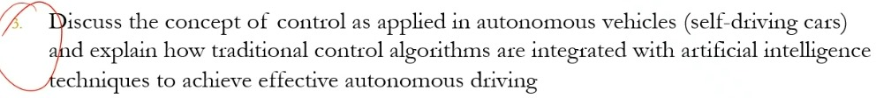
Autonomous vehicles rely on sophisticated control systems to navigate safely and efficiently. These systems combine traditional control algorithms with artificial intelligence (AI) techniques to achieve full autonomy as explained below
Concept of Control in Autonomous Vehicles
Control in autonomous vehicles involves:
- Perception: Sensors (LiDAR, cameras, radar) gather real-time data about the vehicle’s surroundings.
- Decision-Making: AI algorithms process sensor data to make driving decisions (e.g., lane changes, stopping).
- Actuation: Traditional control systems execute physical actions (steering, acceleration, braking).
The control hierarchy includes:
1. High-Level Planning (Strategic Control): Determines the optimal route using GPS and map data.
2. Mid-Level Decision-Making (Tactical Control): Handles lane-keeping, obstacle avoidance, and traffic rules.
3. Low-Level Actuation (Operational Control): Controls vehicle dynamics (e.g., PID for speed control).
Traditional Control Algorithms in Autonomous Vehicles
Traditional control methods provide stability and precision:
- PID Controllers: Used for maintaining speed, following distance, and lane centering.
- Model Predictive Control (MPC): Optimizes trajectories while accounting for constraints (e.g., avoiding collisions).
- State Estimation: Kalman filters fuse sensor data to estimate the vehicle’s position and velocity.

Integration with AI Techniques
AI enhances autonomy by handling complex, unpredictable environments:
- Perception:
- Computer Vision (CNNs): Identifies objects (pedestrians, traffic signs).
- Deep Learning: Processes LiDAR/radar data for 3D mapping.
- Decision-Making:
- Reinforcement Learning: Trains the vehicle to handle rare scenarios (e.g., merging in heavy traffic).
- Behavior Prediction: Models other road users’ actions using probabilistic AI.
- Path Planning:
- Neural Networks: Generate optimal paths in dynamic environments.
- End-to-End Learning: Some systems use deep learning to map sensor inputs directly to control outputs (e.g., NVIDIA’s PilotNet).
4. Effective Integration
The synergy of traditional control and AI ensures:
- Safety: Traditional control provides reliable, interpretable actuation.
- Adaptability: AI handles uncertainty (e.g., jaywalking pedestrians).
- Redundancy: Hybrid systems fall back to traditional methods if AI fails.

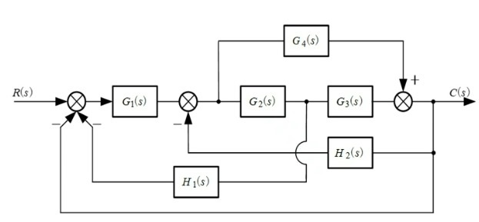
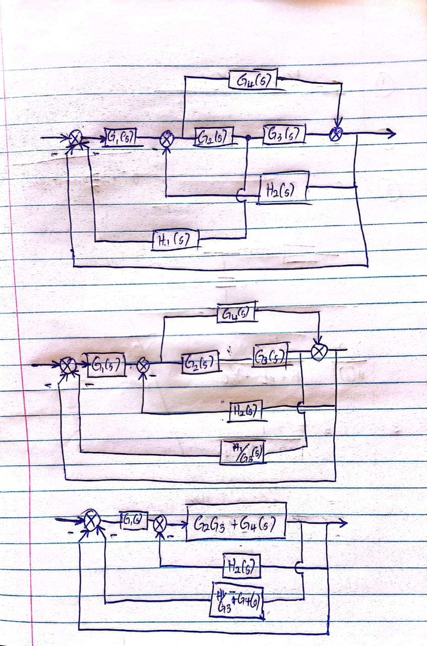
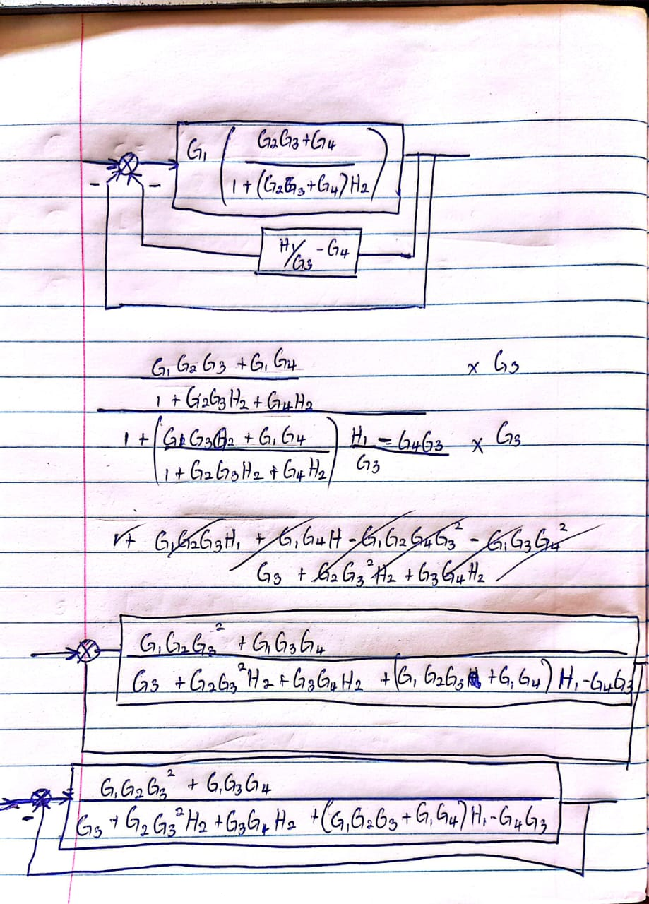
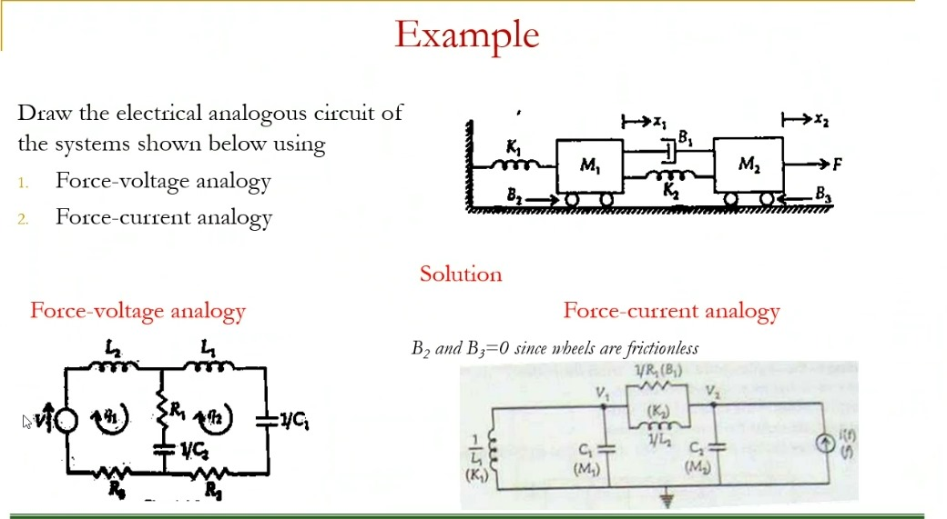
1. Force-Voltage Analogy (F-V)
- Mechanical → Electrical Mappings:
  - Force (F) → Voltage (V)
  - Velocity (v) → Current (I)
  - Mass (M) → Inductance (L)
  - Spring (K) → Inverse Capacitance (1/C)
  - Damper (B) → Resistance (R)
2. Force-Current Analogy (F-I)
- Mechanical → Electrical Mappings:
  - Force (F) → Current (I)
  - Velocity (v) → Voltage (V)
  - Mass (M) → Capacitance (C)
  - Spring (K) → Inverse Inductance (1/L)
  - Damper (B) → Conductance (1/R)
